MIH Nikon Eclipse E1000 – guide to users

Important:
- This is a motorized microscope. Use the software to control microscope parts whenever possible to avoid damage to parts.
- Users are responsible for their own data backup. The computer harddisk has a limited capacity and periodic cleanup will be done.
- Please see the “precautions” listed on the user handouts and posted in the microscope room.
- Do not allow unregistered users to use the microscope (or any other MIH facilities).

Precautions - E1000 microscope:
- Never take any objective out.
- Use of oil is allowed only on 100x objective (Make sure your slides have coverslips). Please follow proper clean up procedure after using oil.
- The 100x objective has a retractable tip, which is spring-loaded to avoid damage. Make sure the tip is in the extended position when you are using it. To do this, turn the tip anti-clockwise and the tip should be released.
- Remove excess oil from slide before switching from 100x objective to any other objectives.
- Do not change torque settings on focusing knob.
- Do not turn left and right focusing knobs in different directions at the same time.
- Do not touch motorized parts of the microscope when they are moving.

Precautions – mercury (fluorescence) lamp:
- If someone has used it in a previous session (or when you notice the lamphouse is still warm), allow the lamp to cool down 30 minutes before restarting.
- Never touch the lamp(hot!), lamphouse or surrounding area while the lamp is lit or within 30 minutes after switching off the power.
- Do not cover the lamphouse with the microscope cover – the heat from the lamp can melt the plastic cover.
- No flammable materials in the proximity of the lamp.
- Do not splash water onto the lamp.
- In case of lamp burst – leave the room and notify persons in charge.

Precautions - computer:

- Do not use computer for purposes other than microscope image capture/processing.
- Do not change configuration of computer – no downloading of software/drivers.
- Always use your own profile for Simple PCI. (data saved in other users’ folders will be discarded).

Power up sequence – turn on the power in the following order: 1. Microscope, 2. Fluorescent lamp (if necessary), 3. CCD Camera (Hamamatsu), 4. Open Simple PCI (imaging software).

Note on mercury (fluorescent) lamp: to turn on the lamp – turn power on, then press and hold ignition button for 3 seconds. The “ready” lamp should come on (it may flicker for a while before stabilizing). If it does not turn on, power off and wait 10 minutes before trying again. If it fails to light up, tell the administrator/coordinator.

Starting to use the microscope:
Perform steps 1 to 14 as described in the manual.
Note: When focusing on a specimen, always start with the lower magnification objectives (e.g. 4x or10x) first and move up to higher mag.

Note:
For more information on Kohler illumination (step 14), go to
http://www.microscopyu.com/tutorials/java/kohler/

Position of beam splitters (see fig 1.2):
Both in – eyepiece
Top out, bottom in – 35mm camera
Top in, bottom out – CCD camera
Both out – CCD camera

Addition lens on top of condenser:
- For brightfield illumination (including DIC): condenser top lens – push in (swing the lens OUT of the lightpath) when using 4x objective ONLY (see fig 1.1). You can see the top lens through the opening on the specimen stage. When using 10x or above, put the top lens back INTO the lightpath for optimal illumination, otherwise you might get artifacts on your image.

Mouse Imaging and Histology Core, University of Toronto

Nikon E1000 Fluorescence microscope

Contents

Power up sequence – Page 2
Turning on fluorescence light source – Page 2
Switching between eyepiece and camera view – Page 2
Initial setting up of microscope optics – Page 3-7
Logging on and starting up Simple PCI – Page 8
Turning on illumination (getting live image on eyepiece/screen) – Page 8
Bright field monochrome image capture – Page 8
Fluorescence monochrome image capture – Page 9
Bright field 3 colour image capture – Page 9-10
Use of DIC mode – Page 11
Using 100x oil lens – Page 11
Using 35mm camera – Page 12
Epi-fluorescence – brightness and exposure time – Page 12
Setting binning mode – Page 12
Automated Z-stack capture – Page 13
Scale bar and measurement – Page 14-15
Wavelengths of filter cubes – Page 15
Deconvolution and image processing instructions for simple PCI - Page 16-18

Pictures of microscope parts:

Condenser, polarizer, condenser top lens slider – Page 2a
Condenser focusing knob – Page 2b
Position of beamsplitter (for eyepiece/camera viewing) – Page 2c
Names of component parts – Page 19-20

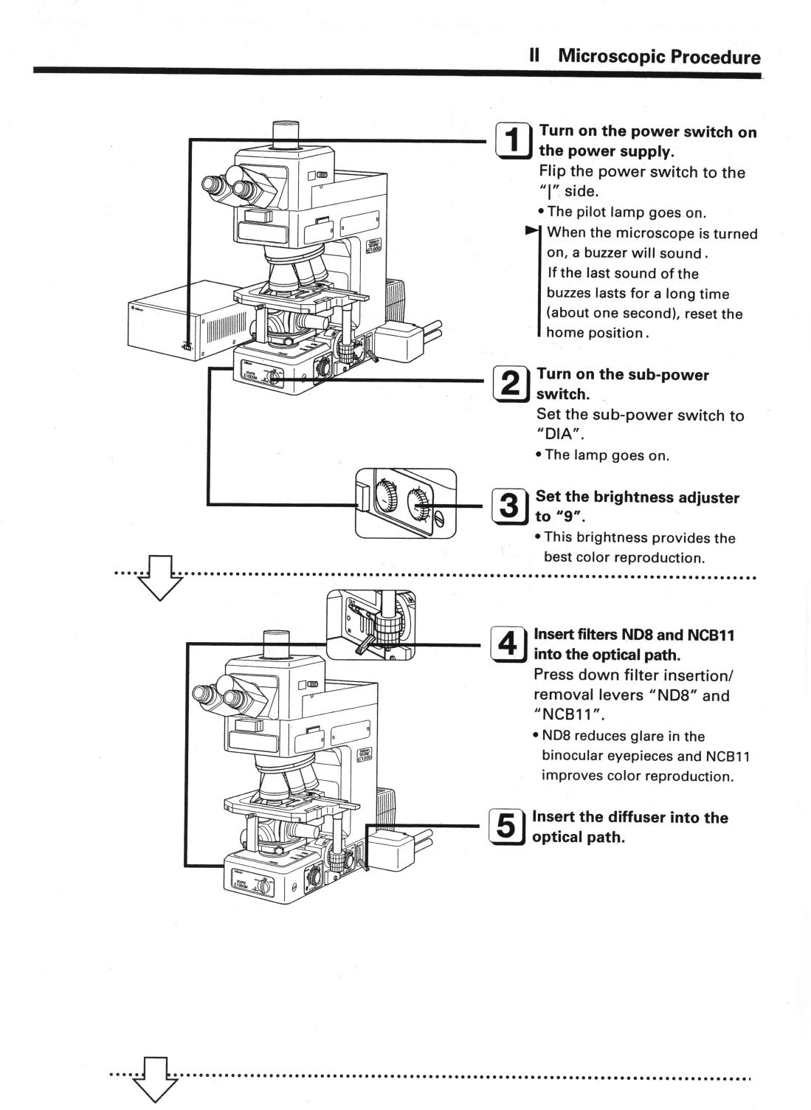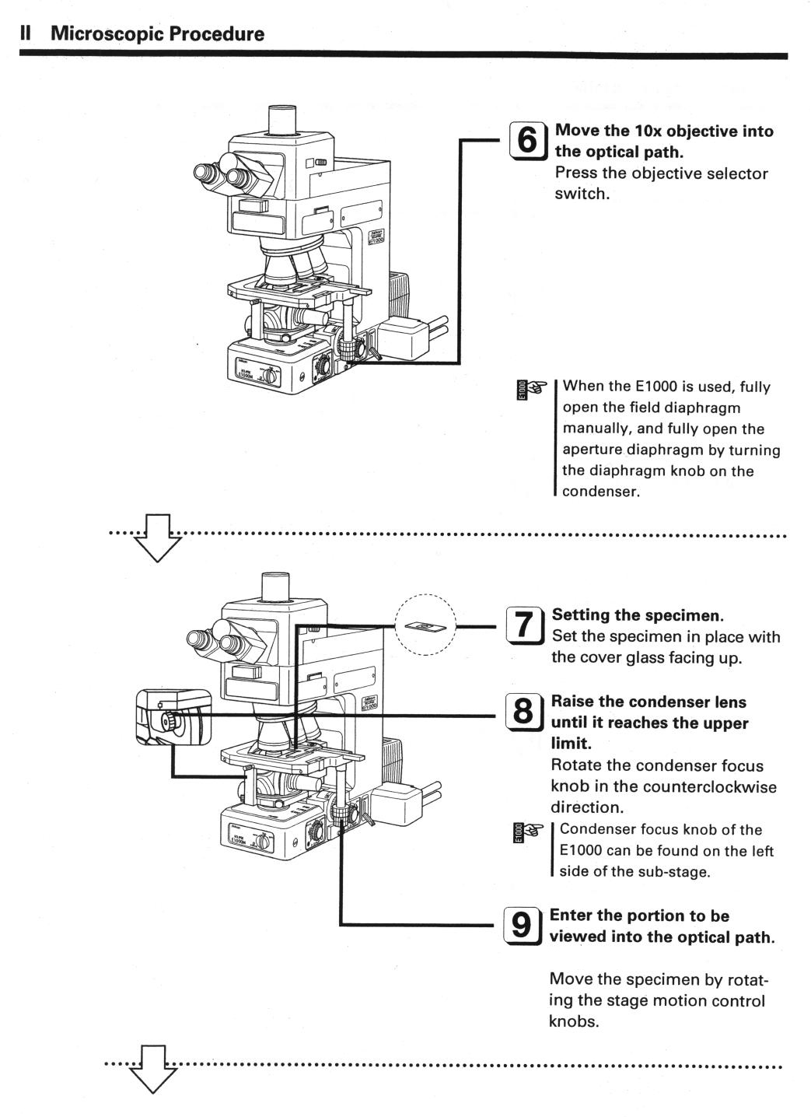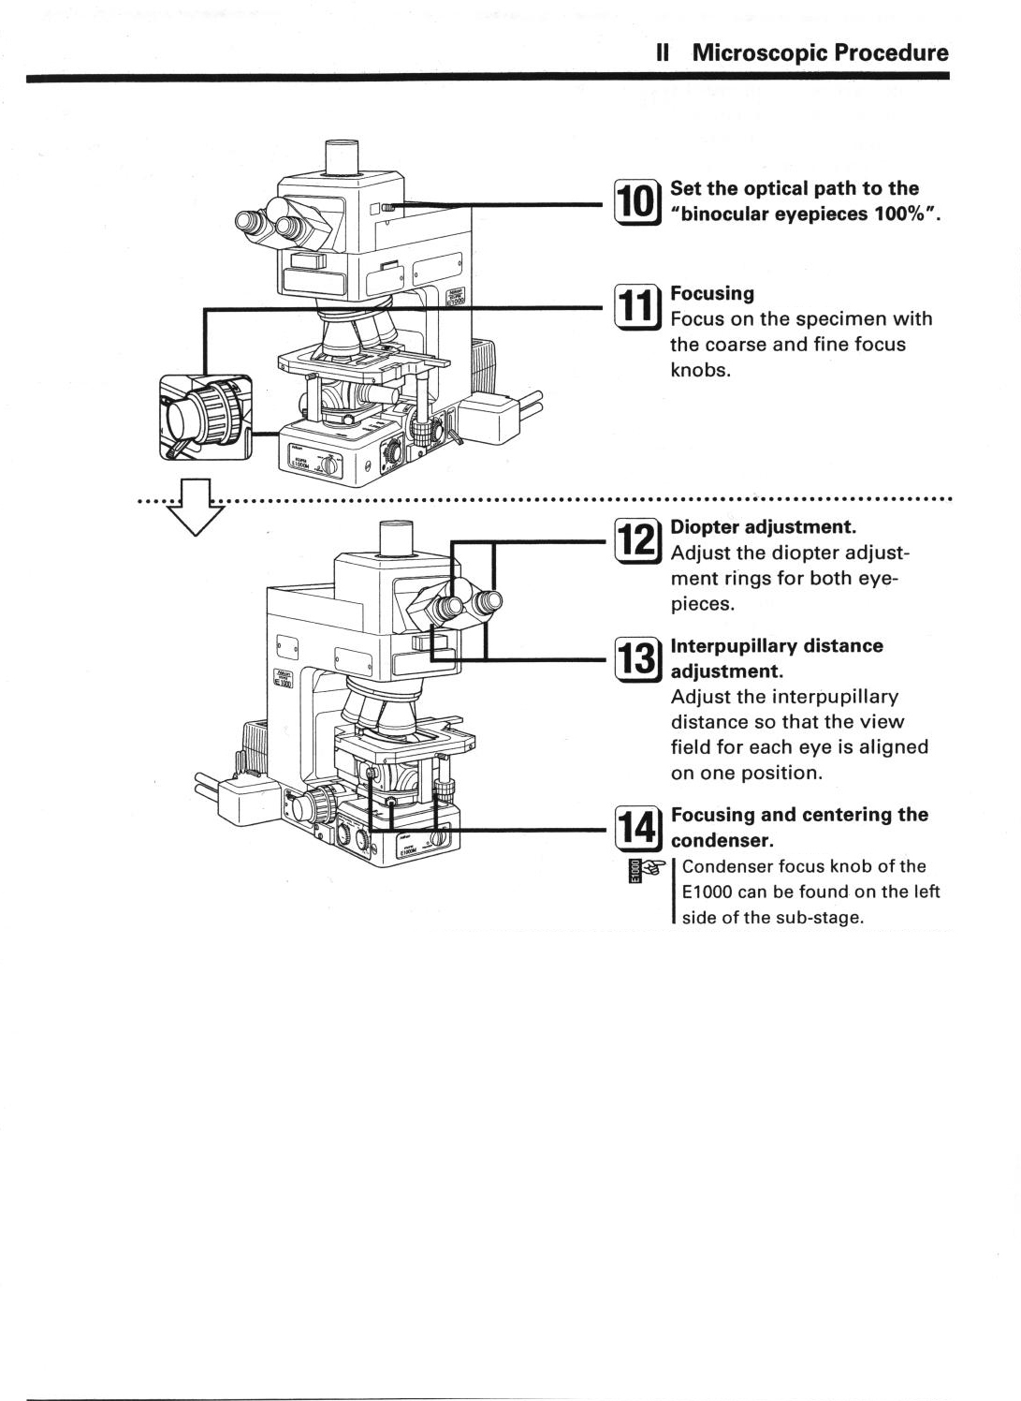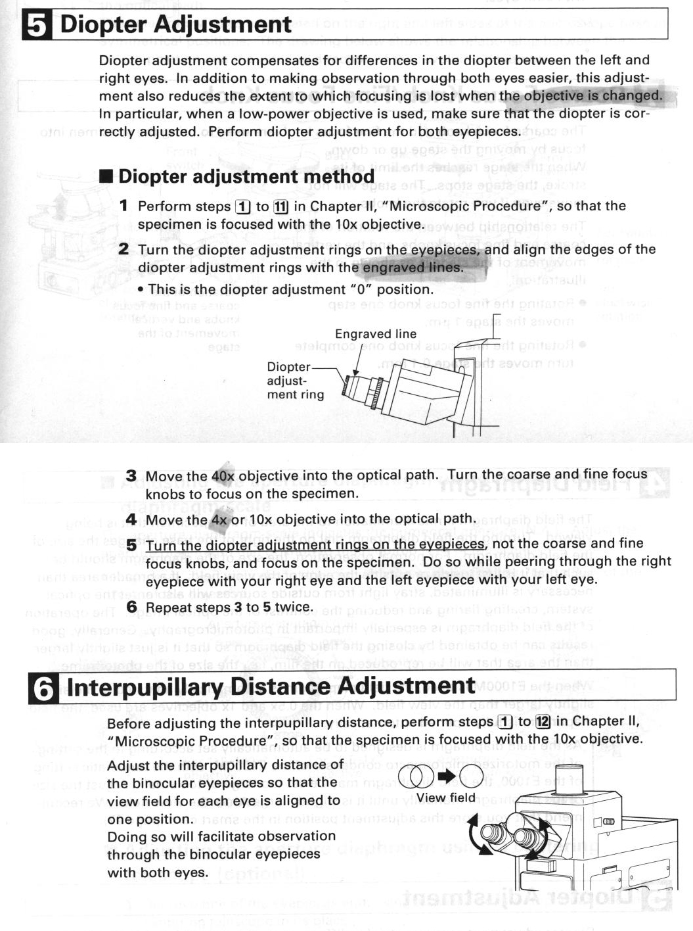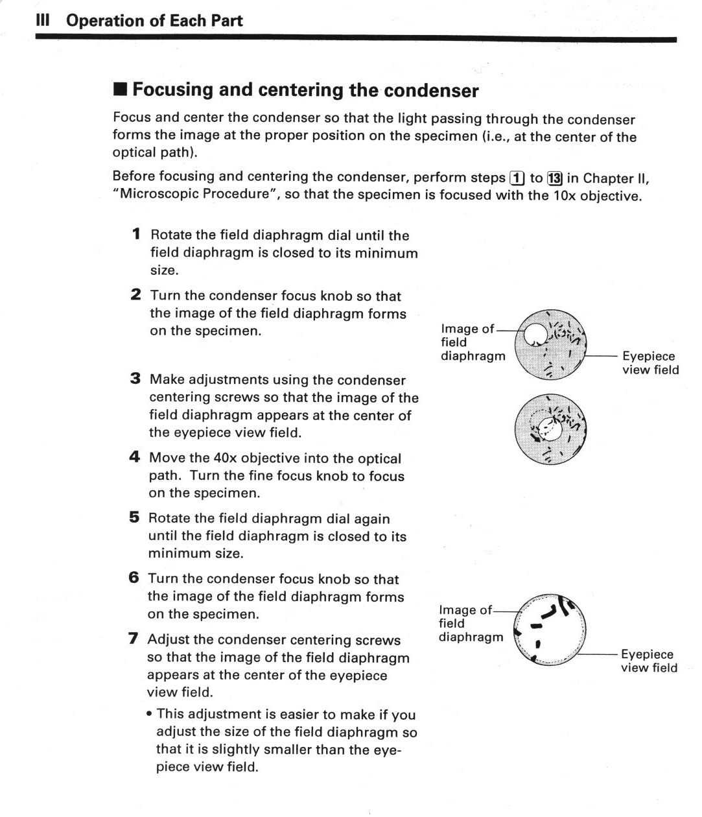

Simple PCI - Starting up:

- Log on to the computer at the “user” level. The password is also “user”.
- Open Simple PCI. (Ignore “failed to update regedit” dialog box – click “ok”)
- Under “File” > “Manage Profiles” – choose YOUR profile (do not use any other profiles except your own) : highlight your name then click “close”.
- Click the camera icon to open the camera control window.

Simple PCI
Steps for getting live image on screen/eyepiece
- Follow the general start-up steps, i.e., turn on the microscope, camera, computer, log-in at the user level, open Simple PCI, choose your user profile (highlight your user name and click “close”).
- Click camera icon. The “Capture” window will come up.
- On the “sensor” tab of the “capture” window, make sure the basic settings are defined, e.g., choose “monochrome image”, “IIDC 1394 Digital Camera” and “BF mono” (fig. 2.8a).
- For eyepiece viewing, click “focus” to turn on illumination (make sure the beamsplitter is at the right position for directing image to eyepiece).
- To display live image on screen, first set beamsplitter to the screen position. Do autoexposure (Fig. 2.3). After the software has determined the right duration of exposure, the light will be turned off. Now click “focus” to turn light back on and the live image will be shown on the screen.
- Click “abort” to turn off illumination.

Simple PCI
Procedures for image capture – brightfield monochrome image

- Make sure sliders (beam-splitter) settings is correct for image capture on CCD camera (see page 2c).
- Make sure Lamp brightness is at “preset” position (the dial on your left side).
- To get the right illumination, first select “monochrome image” – figure 2.1.
- Select “BF mono” (fig. 2.2).
- Click AutoExposure. Select “brightfield” on dialog box (figure 2.3).
- To get live picture on screen – click “focus” (figure 2.4).
- Adjust focus or move specimen if necessary. Adjust exposure time by clicking up/down arrow or typing in the desired exposure time.
- If you want to do autoexposure again or proceed to capture the image, you have to click “abort” to stop the live image.
- Click “Capture 1” to capture image (figure 2.5). DO NOT use “capture” button.
- If you need to embed a scale bar in the picture, do it now (see section on “loading a scale bar”).
- Click the “Save” button to save the image: choose “original image” (figures 2.6 and 2.7). If you have embedded a scale bar, choose “display image plus all layers”.
- It is advisable to go to your folder under C:\ AAProfiles\your lab’s subfolder\your username\mono images (or “color image”, “data files” ,etc) to check if your image is there before proceeding further.

Simple PCI
Procedures for image capture – fluorescence monochrome image

- Make sure sliders (beam-splitter) settings is correct for image capture on CCD camera (see picture displayed). Also make sure fluorescent light is on.
- To get the right illumination, first select “monochrome image” – figure 2.1.
- Select the right filter set for your fluorochrome, see figure 2.2.
- Click AutoExposure. Select “darkfield” on dialog box (figure 2.3).
- To get live picture – click “focus” (figure 2.4).
- Adjust focus or move specimen if necessary. Adjust exposure time by clicking up/down arrow or typing in the desired exposure time.
- If you want to do autoexposure again or proceed to capture the image, you have to click “abort” to stop the live image.
- Click “Capture 1” to capture image (figure 2.5). DO NOT use “capture” button.
- If you need to embed a scale bar in the picture, do it now (see section on “loading a scale bar”).
- Click the “Save” button to save the image: choose “original image” (figures 2.6 and 2.7). If you have embedded a scale bar, choose “display image plus all layers”.
- It is advisable to go to your folder under C:\ AAProfiles\your lab’s subfolder\your username\mono images (or “color image”, “data files”, etc) to check if your image is there before proceeding further.

Simple PCI
Procedures for image capture – brightfield RGB image

- Make sure sliders (beam-splitter) settings is correct for image capture on CCD camera (see picture displayed).
- Make sure Lamp brightness is at “preset” position (the dial on your left side).
- Select “three color image” on top right-hand corner – figure 2.1.
- Select “BF red” at the red channel, “BF green” and “BF blue” for the remaining channels (fig. 2.2).
- Click AutoExposure. Select “brightfield” on dialog box (figure 2.3). Select the color channel for exposure. Do autoexposure for R, G and B channels one by one.
- To adjust focus, go to “Nikon E1000” tab (figure 2.8b) and click on the “FITC” filter cube. Then click “focus” to bring on the light. Green is generally used to focus the specimen for BF-RGB pictures.
- Go back to the “Sensor” tab. Adjust focus or move specimen if necessary. Adjust exposure time by clicking up/down arrow or typing in the desired exposure time.
- If you want to do autoexposure again or proceed to capture the image, you have to click “abort” to stop the live image.
- Click “Capture 1” to capture image (figure 2.5). DO NOT use “capture” button.
- If you need to embed a scale bar in the picture, do it now (see section on “loading a scale bar”).
- Click the “Save” button to save the image: choose “original image” (figures 2.6 and 2.7). If you have embedded a scale bar, choose “display image plus all layers”.
- It is advisable to go to your folder under C:\ AAProfiles\”your lab’s subfolder”\”your username”\mono images (or “color image”, or “data files”) to check if your image is there before proceeding further.

DIC for enhancing contrast (for bright field illumination)
Before you start:
- For all objectives fitted with DIC prisms (10x, 20x, 40x), the top lens of the condenser has to be moved INTO the lightpath (by pulling slider OUT, see page 2A) for optimal illumination. For unstained cells, it might be easier to find and focus the specimen using the 4x objective (condenser top lens OUT).
- For optimal results, make sure Kohler illumination is set (condenser is focused and lightbeam is centered).
- Make sure polarizer (see page 2A) has not been moved out of the lightpath by the previous user.

- Make sure that “monochrome image” is chosen on “Sensor” page (Fig 2.1).
- Direct light to the eyepiece first. Bring 4x objective into lightpath.
- Choose “BF mono” and click “Focus” to turn on illumination. Get the specimen into focus under 4x objective (condenser top lens OUT).
- Stop the live image by clicking “Abort”.
- Switch to a higher magnification objective (bring up the Nikon E1000 screen – Fig 2.8b, and click on the 10x, 20x or 40x button).
- Go back to “Sensor” screen. Choose “DIC-L”, “DIC-M” or “DIC-H” by clicking on the drop-down menu below the “filter set-up” button (look at the objective lens - the DIC mode is printed on the side of the lens).
- Turn on illumination by clicking “Focus” (the other components of the DIC optics will be automatically rotated into the light path once you activate the system using either “focus” or “autoexposure” or “capture 1”).
- Readjust focusing if necessary. If you are not getting any image, check condenser top lens and/or Kohler illumination.
- To vary the contrast, rotate the polarizer (see page 2A). Note: since the polarizer varies the amount of light reaching the camera, you might have to re-do autoexposure for image capture.

Use of 100x oil lens
- Use of oil is allowed only on 100x objective (Make sure your slides have coverslips). Please follow proper clean up procedure after using oil.
- The 100x objective has a retractable tip, which is spring-loaded to avoid damage. Make sure the tip is in the extended position when you are using it. To do this, turn the tip anti-clockwise and the tip should be released.
- Remove excess oil from slide before switching from 100x objective to any other objectives.

Cleaning up immersion oil on 100x objective lens:
- Use the lens paper supplied, do not use Kimwipes or Kleenex.
- Move the nosepiece so that the 100x is pointing out.
- Blot away excess oil with lens paper.
- Gently apply 100% ethanol to objective lens using Q-tips (do not rub lens with Q-tips).
- Gently wipe the lens with lens paper.

35mm camera-
Diopter adjustment: in the viewfinder, look at the reticule (which appears as dark cross in brightfield) with one eye, turn diopter until the reticule becomes sharp – i.e., the two separate lines can been resolved. Then adjust microscope focus until the specimen is in focus. Use telescopic zoom adapter (fits onto viewfinder) to help focusing if the specimen looks too small in viewfinder to properly focus.

35mm camera-
Adjusting white balance (to get the right color temperature) for bright-field pictures:
- Make sure the NCB11 filter is IN (on your left side) – for daylight correction.
- Set the illumination to 8.5 to 9V.
- Use ND filters if the light gets too bright for viewing using eyepiece.

Epi-fluorescence – tips on brightness
- To avoid excessive photobleaching of sample, you can cut down on brightness of mercury lamp when you are scanning the sample for the right spot: insert ND filter slider on your right hand side (ND16 means reduction to 1/16th of the full strength).
- Note that when you are focusing or scanning the sample (moving the x-y stage) based on screen display, the exposure time may be too long to provide you with a satisfactory frame-refresh rate, so you will not be seeing the effect real-time. It is recommended that you use the eyepiece for focusing and scanning under such low light circumstances (the longest auto-exposure time is 10 seconds, beyond which the software cannot decide on the exposure time – you have to manually set it).

Simple PCI - Setting binning mode for image capture
Binning increases sensitivity of CCD camera, but reduces resolution. To set binning, on “Capture” window, click “Device set up” button. On right side of the device window, there is a number of binning choices to choose from. Always choose “no binning” (i.e., binning = 1) unless the signal is too low for image capture.

Simple PCI-

Capturing Z-stack

Follow these steps to get a sequence of images at various z positions, starting from bottom (“negative” z: the stage is at a lowered position), passing through “zero” position (here taken to mean the sharpest focused position), and finishing at the top (“positive” z, the stage at its highest position of the user-defined range).
Note: Smallest Z step is 50nm.

- On “Sensor” tab, choose “focus” to get live image. Get all the settings (e.g. filter set, autoexposure time) right and focus on specimen to get sharp image.
- Go to “Z-focus” tab (fig. 4.0), click the “0” button and choose “set to zero” (fig. 4.1).
- To set top position, change focus until the “position” displays a positive z number (or type in the desired z coordinate), then check the box “top”. This will be the upper limit of your z range (fig. 4.2).
- Click the “0” button and choose “move to zero”. This bring you back to the sharp position.
- To set bottom position, change focus until the “position” displays a negative z number (or type in the desired z coordinate), then check the box “bottom”. This will be the lower limit of your z range.
- Once all three z coordinates have been set, go back to the “sensor” tab > “abort” > click “sequence” button (fig. 4.3).
- Give a name to the sequence file (fig. 4.4). Click “save”.
- Choose scan type: “z scan”, and “pattern” (fig. 4.5) > “next”.
- Click the up arrow below the “retrieve z limits” (fig. 4.6) to get the coordinates previously defined. This also specifies movement of the stage from bottom to top. You can specify the increment (in microns) you want > “next”.
- Click “finish” on the “scan list” page (fig. 4.7).
- Click “start” on the “simple PCI sequence capture” page (fig. 4.8).
- The sequence of images will be captured and stored in the “data files” folder under your profile. Click “ok” to close the active window (“capture” window). The details of the newly captured .cxd file should be shown in a separate window.
- If you want to shoot another z sequence, the software may use the same top and bottom coordinates and increments as default values. You can redefined the limits on the “z focus” page, then go to step 6 above. Use the “back” button to go back to the “scan type” and “scan ranges” page to make sure the right values are retrieved for your new sequence.

Simple PCI - Loading a scale bar – image just captured
Note: The default camera adapter mounted on the microscope is 0.7x. Do not change the camara adapter without the approval of the facility coordinator.

- Capture an image, then click the down arrow on the scale bar button (fig. 3.8a). Note: see also fig. 3.5 if you are opening an image which is previously saved (scale bar button appears at the bottom of the window).
- Choose calibration (fig. 3.6).
- On calibration screen, click “load”, then “open” the “0.7x-Cimaging.cal” file (fig. 3.7). If 1.0x camera adapter has been mounted, open 1.0x-Cimaging.cal instead.
- You can see the files loaded on the calibration screen, click OK. Note: If you can see the files loaded on the screen but the software tells you “error on loading...file does not exist”, ignore the message.
- On the image window, click the down arrow on scale bar button again, you will see the available calibration files. The software chooses the cal file corrected for the binning mode at which you have taken the picture*, but you have to manually choose the objective magnification (fig. 3.8b).
- Then click the scale bar button. A scale bar should appear on the screen (fig. 3.9).

*You can check to see if the software has chosen the right binning mode by looking at the “magnification” setting on the “calibration” window – e.g., it should show 2 if you have selected 2x2 binning at image capture.

Simple PCI - Loading a scale bar – for previously saved image, proceed as follows:

- Load the calibration file (e.g., 0.7x-Cimaging.cal) as described in steps 1 to 3 above. in the “calibration” window, highlight the title of the file with the right objective magnification, e.g., “10x plan fluor” (fig. 3.8c).
- Then manually change the “magnification” listed above, i.e., change it to 2 if you know that your image has been taken with 2x2 binning. Then click “OK”.
- When you click the down arrow on the calibration button on the image window, you will see the usual choice of loaded cal files, plus an additional “10x plan fluor” which is already selected by default (fig. 3.8d). This is the one to use for 2x2 binning. Click on the scale bar button to show scale bar.

Simple PCI - Measuring diagonal lengths on images

- Open an image, load the proper calibration file (See “loading a scale bar” section). Click “ROI” button (“Activate ROI shapes layer”, fig. 3.10). A group of buttons should appear on the right side of the image window.
- Click the straight line tool (fig. 3.11). You might have to unselect other tools if they are chosen by default.
- Use the mouse to draw a line (or multiple lines) that corresponds to the length you want to measure.
- Click “measure image” button (fig. 3.12). Check the “length” box on the “Select Measurement” window (fig. 3.13). Check the “selected only” box. Then click “measure”.
- Name the data file and click save. Click OK on the “data component” window (fig. 3.14).
- A new window will appear, showing the name of the .cxd file that you have created, together with the measured length of your line(s) in microns. Click on any of the measurements and a small image will come up, showing the active line in red and all other lines in green (fig. 3.15).
- The information will be stored in the .cxd file, and you can access the information later by opening the file and looking under “object data”.

Available filter cubes (wavelengths in nm):

Filter cube | Excitation | Dichromatic mirror | Barrier filter
DAPI (Violet excitation) | 330-380 | 400 | 435-485
FITC (Blue Excitation) | 460-500 | 505 | 510-560
TRITC (Green excitation) | 528-553 | 565 | 600-660
Cy-5 (Red excitation) | 590-650 | 660 | 663-735

eGFP: EX 470/40, EM 525/50, DM 495LP

Deconvolution and image processing instructions for Simple PCI:

1. [Example data - TEST] Import data (OPEN>DATA FILE, then select needed *.cxd Z stack) from FILE menu. Adjust contrast if necessary, using the button on the upper row of the data window (next to "colors overlay" button)
2. Delineate subregion to be examined (in data window "red square" button pair - buttons 13 and 14. If you dont like the regions defined, you can delete it under second button pair, or expand it (left or right mouse button click). To delineate this area for Z stacks, I prefer to have the Z file sequence playing in the "back and forth" focus mode (second button to the right in the lower left hand corner of the data window.

2a. [Example data - TEST delin] Save delineated region if needed,(note that the file sequence must not be actively playing at the time). First ensure that the "red button" of the delineate button pair (button 13 on the upper row of the data window) IS depressed. THEN, under the FILE menu in the upper right hand corner of the simple PCI menu, select EXPORT IMAGE SEQUENCE > DISPLAY IMAGE. You will then name the file and the file location (default saves the cropped Z stack as a *.cxd file BUT you can also select on the pulldown menu the IMAGE FILE option. This will be used when exporting the FINAL FILE to the true 3D NEURAL RECONSTRUCTION PROGRAMS.

3. [Example data - TEST decon] Deconvolve the Z stack if needed (buttons 9 and 10 on the upper row of the data window). Remember to set the proper parameters for your file first using button 9. The numerical aperture can be read off each of the scope lenses (0.3 for 10x, 0.5 for 20x, 0.75 for 40x, 1.3 for 100x). Refractive indcies are shown on the pulldown menu. Emmision wavelength should be known from the fluorophore utilized, or can be estimated from the emission tabs on the scope. The Z step known from the users image collection data (typically 1 um for 20x, 0.5 um for 40x, 0.25 um for 100x oil). Once these values have been applied, select the form of deconvolution using button 10 (2D blind decon. is the slowest). Following deconvolution, to save the result to a new file, select YES on the export images window which appears; hit the BROWSE button and type a new file name for the deconvolved data. The date will be recompiled and stored. for our average files (~70% subselected region from at 40 step 20X file ~25 MB) this takes approximately 40 minutes (1 min per step) on the E1000 linked computer (clipping of the Z stack can reduce time, however remember that out of focus planes are required above and below the object examined for effective deconvolution.

3a. If, looking at the final result, you wish to CUT layers from YOUR stack, choose FILE>EXPORT IMAGE SEQUENCE>ALL>IMAGE FILES (from pulldown menu), then hit BROWSE to choose the master file name. This will result in the generation of a stack of individual TIFF images of number 1-X. Delete any numbers to be eliminated from the stack, then reinegrate the stack by using FILE>IMPORT IMAGES> then in the window which appears, choose "Source" then click on THE FIRST of the images in the designated series; then click "Dest." and provide a file name for the reitegrated stack [Example data - TEST decon short.cxd].

4. To do a 3D recon of the Z stack at this stage, click on the "Field Image Montage" folder in the left hand WINDOW. THEN, right mouse click on the DATA in the right hand window. This will open up a series of options. Choose "Create Movie > 3D rotate - maximum projection". You will be asked to name your new file [Example data - TEST 3D decon movie]. The movie will then be created.

5. However, to perform detailed 3D reconstructions, use the Decon data [Example data - TEST decon short.cxd].
Adjust contrast, - Not happy with the contrast you previously applied? Click button #23 on upper row of data window (just prior to main contrast button).
To delinate an area of interest, right click on the image in the image window. This will bring up a menu with options which include "Measurement ROI Layer" > activate ROI shapes layer.

6. On the ROI shapes menu (right hand side of the data image window), click on the "Identify Objects" button (button in the lower right hand corner of Menu (Green mountains). With the Z stack at the optimal image in the stack (for the desired object), set the threshold for the object under study (typically performed using the lower threshold button, the upper I typically keep at max. - 255). Lower threshold values are typically in the 17-25 grey range.

7. Thresholding is typically performed only on the sections shown (don't know why it can't be performed simultaneously on the entire stack), so you may need to go to different layers within the Z stack and perform thresholding again. Once the threshold is set, you will be asked to use "Advanced Detection". If you answer yes, you will see a list of other imaging options which can be performed. In the initial rounds, I typically bypass this option until the full image is captured. Hitting "OK" will bring up the "quantify objects" menu. Hit "OK" without changing values to bypass this menu. If subsequent rounds of image identification are performed, you will be asked if you wish to "append" your new thresholds. Indicate YES. This should allow you to get a reasonable representation of the desired object.

8. When you are ready, you can click on the image window, go to "Measurement ROI Layer" > and at the bottom of the submenu, you will see "erase outside shapes". Clicking on this option will erase EVERYTHING which is not contained in your thresholded boundaries.

9. To save your work at this point, click the FILE menu in the upper right hand corner and select EXPORT IMAGE SEQUENCE > DISPLAY IMAGE. You will then name the file and the file location (default saves the cropped Z stack as a *.cxd file).

10. To remove additional image areas outside of the desired image, right click on the image window to bring up the ROI layer. click "closed polygon" first option in the 5th row of the ROI menu and encircle the desired object. Then click on the image window, and choose "Measurement ROI Layer" > "erase outside shapes". THis will remove addition non-ROI components. If you find you have ERASED TOO MUCH, you can hit the "delete" key at this stage and the polygon will be removed (along with any data which had been "erased", i.e. changes are not permanent until you save the image using FILE>EXPORT IMAGE SEQUENCE>DISPLAY IMAGE.

10a. Performing delineation on straight decon. image files by hand may actually be better overall.

11. When done, use FILE>EXPORT IMAGE SEQUENCE>ALL, and choose IMAGE FILES from pulldown menu to generate TIFF stacks neede for next program. Hit BROWSE and choose a short simple name for the CNIC program.



